About the project

* Digital twin using Cesium for Unity

Cesium for Unity tutorial:

* 3d buildings
* Autonomous agents (mixamo + Unity animator)
* Cars
* Trees
* Traffic lights

Scripts (Code)

**Waypoint Pathfinding**

These scripts can be found attached to each pedestrian located under the parent game object for each pedestrian (see image below). The game objects below the pedestrians are each pedestrian’s waypoints:

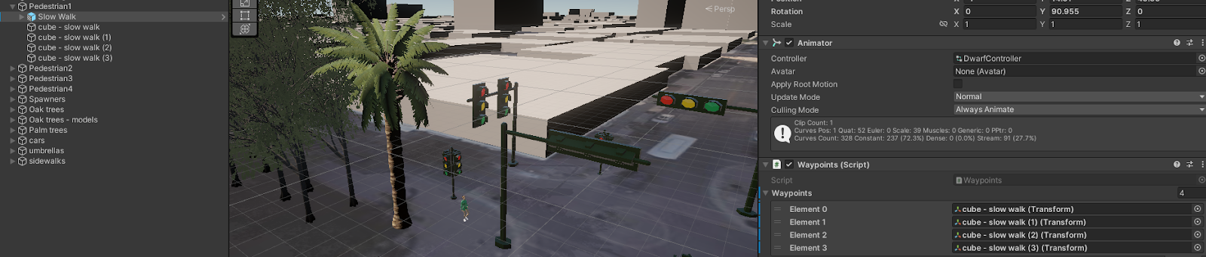

**Waypoints**

* Attach to a pedestrian to program them to follow a path of waypoints at runtime
* The pedestrian follows the path indefinitely as long as the game is in play mode
* Allows the user to set any gameobject as a waypoint

**Four Seconds and Infinite**

* Pedestrian will follow a path of waypoints, but pauses movement for four seconds (‘Four Seconds’) or three seconds (‘Infinite’) at the current waypoint before moving on to the next one
* Use this script to simulate a pedestrian stopping at an intersection to look for cars before crossing the street
* The pedestrian will follow the path of waypoints indefinitely
* The pedestrian will reach the end of the path of waypoints and go back to the beginning as long as the game is in play mode
* The number of seconds that the pedestrian pauses can be adjusted in the script(s)

**Instantiate Scripts (spawn pedestrians at runtime)**

These scripts can be found under the ‘Spawners’ parent object. They can be used to spawn or unspawn pedestrians according to the user’s preferences:

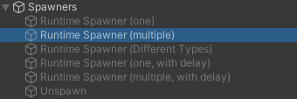

**Instantiate with Delay**

* In play mode, a gameobject will instantiate (spawn) after a delay. Adjust the length of time that this delay is within the script via this line of code:

public float delayInSeconds = 90f *// modify the float value (90f)*

**Instantiate Multi with Delay**

* Functions the same way as the above script, except multiple gameobjects will instantiate after a delay
* Add as many gameobjects as pedestrians to be spawned. Example below:

public GameObject objectToInstantiate; // The object to be instantiated

public GameObject gameobjecttwo; *// This block of code will instantiate two gameobjects. Add more game objects to instantiate more pedestrians*

// Instantiate the object and set its position to the position of this GameObject

Instantiate(objectToInstantiate, transform.position, Quaternion.identity);

Instantiate(gameobjecttwo, transform.position, Quaternion.identity); *// this block of code ensures that the instantiation will be executed for each gameobject created in the above block of code. Be sure to add all created gameobjects into separate ‘Instantiate’ function calls*

**Spawn Multiple**

* Instantiates multiple of the same gameobject/prefab at runtime:

public GameObject prefabToSpawn; // Assign the prefab in the Inspector

* The amount of gameobjects instantiated can be adjusted within the script:

public int numberOfObjectsToSpawn = 10;

* The radius in which the gameobjects are instantiated can also be adjusted:

public float spawnRadius = 10f;

**Spawn at Runtime**

* Spawns one gameobject when the user enters play mode

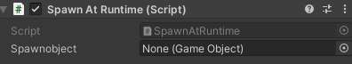

**Spawn Different Types**

* Instantiates multiple different gameobjects using prefabs when play mode is entered:

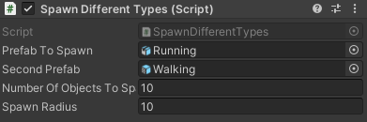

* The value for the amount of gameobjects to be spawned can be adjusted in the script:

public int numberOfObjectsToSpawn = 10;

* The radius within which the gameobjects are spawned can also be adjusted:

public float spawnRadius = 10f;

Instantiate(prefabToSpawn, randomPosition, Quaternion.identity);

Instantiate(secondPrefab, randomPosition, Quaternion.identity);

// Instantiate(thirdPrefab, randomPosition, Quaternion.identity); *// this block of code ensures that the instantiation will be executed for each gameobject created in the above block of code. Be sure to add all created gameobjects into separate ‘Instantiate’ function calls*

**Unspawn -** this code isn’t working (yet)

* Instantiates, then uninstantiates a gameobject
* The script can be modified so that there is a delay before the spawned gameobject unspawns

**??**

Adjust the radius around a pedestrian for basic object avoidance.

To hide waypoints in both scene and play mode, disable or remove the ‘Mesh Renderer’ and ‘Box/Sphere Collider’ components. However, to make the waypoints visible in scene mode but invisible in play mode, put (all) waypoints on their own layer separate from the rest of the gameobjects (cars, agents, etc). See ‘Resources’ section.

To use the car textures that come with the ‘car asset here’ asset:

**Inspector —> Shader —> Surface Inputs —> UseColorMap🗹**

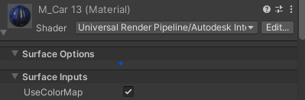

**Resources**

**Cesium for Unity (tutorial):**

<https://cesium.com/learn/unity/unity-quickstart/>

**‘Patrolling AI in Unity with C#’ (‘Waypoints’ script):**

<https://www.youtube.com/watch?v=c8Nq19gkNfs>

**Using Layers in Unity - method to hide waypoints:**

Article: <https://vasundhara.io/blogs/use-layers-in-unity>

YouTube video: https://www.youtube.com/watch?v=A7oA-X0Ukqc

**Import characters and animate them:**

Youtube video, part 1: <https://www.youtube.com/watch?v=-FhvQDqmgmU&list=PLwyUzJb_FNeTQwyGujWRLqnfKpV-cj-eO&index=1>

Part 2: <https://www.youtube.com/watch?v=vApG8aYD5aI&list=PLwyUzJb_FNeTQwyGujWRLqnfKpV-cj-eO&index=2>

**Assets**

**Traffic Lights:**

<https://assetstore.unity.com/packages/3d/environments/urban/city-traffic-lights-pack-free-low-poly-3d-art-154053>

**Oak Trees:**

<https://assetstore.unity.com/packages/3d/hdrp-oak-tree-214007>

**Cars** (10/27/23 - currently deprecated)**:**

<https://assetstore.unity.com/packages/3d/vehicles/land/single-detailed-truck-895>

**Palm trees:**

1. <https://assetstore.unity.com/packages/3d/vegetation/trees/palm-tree-pack-free-214483>
2. <https://assetstore.unity.com/packages/3d/vegetation/trees/coconut-palm-tree-pack-7888>

**Trailer truck:**

<https://assetstore.unity.com/packages/3d/vehicles/land/single-detailed-truck-895>

**Umbrellas:**

<https://assetstore.unity.com/packages/3d/props/exterior/colored-parasols-214006>

**Information on ‘Instantiate’:**

<https://gamedevbeginner.com/how-to-spawn-an-object-in-unity-using-instantiate/>